Section 1: Multiple Choice
1. What is the first step in the troubleshooting process? Answer: b) Identifying the problem.
- Explanation: You can't fix something if you don't know what's broken. The very first step is to figure out exactly what the problem is. This means gathering information, asking questions ("When did it start?"), and seeing the problem for yourself.
2. Which of the following tools is commonly used to diagnose hardware issues by testing electrical connections? Answer: c) Multi meter
- Explanation: A multi meter is a device that can "multi-task" and "meter" (or measure) different electrical properties. Technicians use it to check things like voltage, current, and resistance to see if a component (like a power supply) is getting the right amount of electricity.
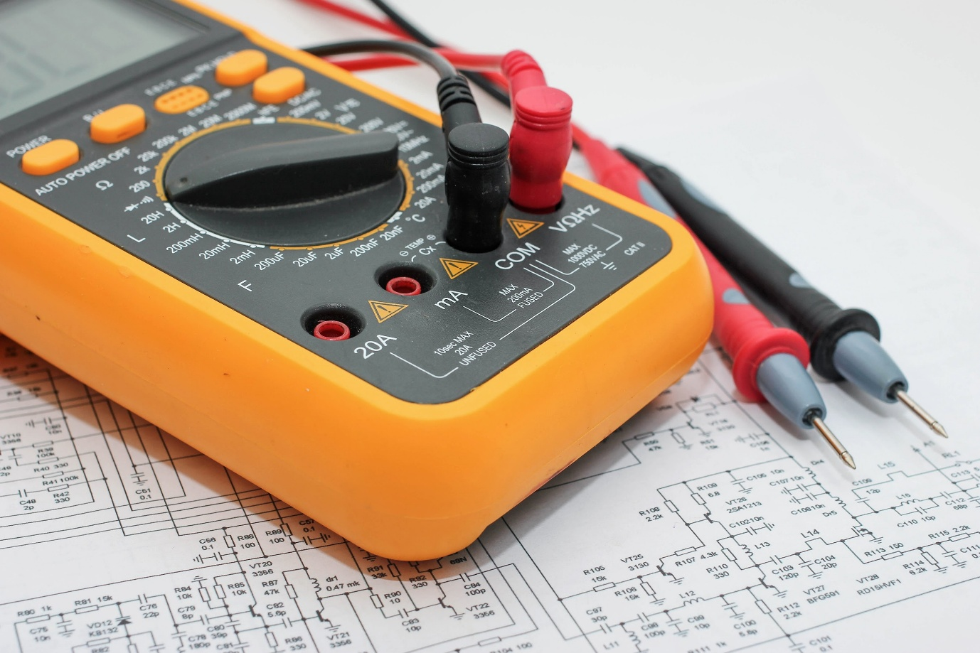
Shutterstock
3. Which Windows utility can be used to view system logs, monitor performance, and diagnose hardware and software issues? Answer: c) Event Viewer
- Explanation: Think of Event Viewer as the computer's diary. It automatically writes down a log of everything important that happens, like when a program crashes or a service fails to start. When troubleshooting, a technician can read this "diary" to find clues about what went wrong.

Section 2: True or False
4. True or False: Safe Mode is a diagnostic mode in Windows that loads only essential system services and drivers, allowing users to troubleshoot and fix problems with the operating system. Answer: True.
- Explanation: Safe Mode is a special, basic version of Windows. It's used when Windows won't start normally. By loading only the most important files, it lets you get into the system to remove a bad driver or a virus that might be causing the problem.
5. True or False: A system restore point is a snapshot of the computer's system files, registry, and configuration settings at a specific point in time, which can be used to revert the system to a previous state if problems occur. Answer: True.
- Explanation: A restore point is like a "time machine" for your computer's settings. Before you install a new program, Windows can create a restore point. If that new program breaks your computer, you can "restore" the system back to the way it was before you installed it. It doesn't affect your personal files like photos or documents.
6. True or False: Ping is a command-line utility used to test network connectivity by sending ICMP echo requests to a target device and waiting for ICMP echo replies. Answer: True.
- Explanation: Ping is like shouting "hello!" across a network and seeing if you get a "hello!" back. You can "ping" a website (like ping google.com) to see if your computer can reach it and how fast the connection is. If you get a reply, you know the connection is working.

Section 3: Short Answer
7. Describe the steps involved in troubleshooting a computer that fails to boot into the operating system. When a computer won't start, you should check things in a logical order, from the simplest to the most complex.
- Check Power: Is the computer plugged in? Is the power strip turned on? Check that the power cable is firmly connected to the computer and the wall.
- Check the Monitor: Is the monitor turned on and plugged in? Sometimes the computer is on, but you just can't see anything.
- Listen for Beeps: When a computer first turns on, it does a quick self-test (called POST). If it finds a serious hardware problem (like bad RAM), it might make a series of beeping sounds. These "beep codes" can tell you what is wrong.
- Check for Error Messages: Does the screen show any message, like "Operating System not found"? This message is a big clue that the computer can't find Windows, possibly because the hard drive has failed or is unplugged.
- Try Safe Mode: If the computer starts to load Windows but then crashes, try restarting it in Safe Mode. If Safe Mode works, the problem is likely a bad driver or software.
- Check Boot Order in BIOS: The BIOS is the computer's basic settings. You can check the "Boot Order" to make sure the computer is set to start from the hard drive where Windows is installed.

Section 4: Practical Application
8. Demonstrate how to troubleshoot network connectivity issues on a Windows computer using the ipconfig command. If your computer can't connect to the internet, the ipconfig command is a great first step. You run it by opening the Command Prompt.
Here’s how you use it to troubleshoot:
- Open Command Prompt: Click the Start menu, type cmd, and press Enter.
- Run the Command: In the black window, type ipconfig and press Enter.
- Analyze the Results: You will see a lot of text, but you need to look for three key things under your "Wireless LAN adapter" or "Ethernet adapter":
  - IPv4 Address:
    - Good: If you see an address like 192.168.1.5 or 10.0.0.10, it means your router has given your computer a valid IP address.
    - Bad: If you see an address that starts with 169.254..., it means your computer tried to get an address from the router but failed. This is a big problem.
  - Subnet Mask: This should be present, usually 255.255.255.0.
  - Default Gateway:
    - Good: This is the IP address of your router (e.g., 192.168.1.1). If this address is present, your computer knows where to send internet traffic.
    - Bad: If this is blank, your computer has no idea where the router is and can't get to the internet.
Based on these results, you know what to try next. For example, if you have a 169.254... address, the problem is between your computer and the router (maybe a bad Wi-Fi connection or a bad cable). If you have a good IP but no internet, the problem might be with the router itself or your Internet Service Provider.

Section 5: Essay
9. Discuss the importance of effective communication skills in a helpdesk or technical support role. In a helpdesk or technical support role, being good with people is just as important as being good with computers. Effective communication skills are essential for solving problems efficiently and keeping customers happy.
The first part of good communication is active listening. When a user is upset because their computer isn't working, they are often frustrated or stressed. A good helpdesk person must listen patiently, without interrupting, to understand the entire problem. They need to ask clear, simple questions to get the right information, rather than assuming they know the answer.
The second part is translating technical information. Most users don't understand technical terms like "DNS," "IP address," or "driver." A good support person can explain what is wrong and how to fix it in very simple, basic English. They must avoid confusing jargon and guide the user through the steps one by one. This builds trust and makes the user feel capable, not stupid.
Finally, empathy and patience are key. The support person is the face of the IT department. By staying calm, being polite, and showing the user that they understand their frustration ("I know this is very frustrating, I'm going to help you fix it"), they can turn a negative experience into a positive one. Good communication makes the user feel supported, while bad communication can make them feel even worse, even if the technical problem gets solved. Therefore, communication is the bridge between the technical problem and the human solution.

